Der Elektromotor

- Elektromotoren wandeln ……………………………………………………………………………………………………….. in ………………………………………………………………………………………………………..um.

Grundregeln
1. Regel

- ……………………………………………………………………………………………..………….. …………………………………………………………………………………..…………………………………..
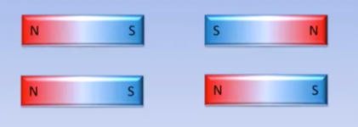
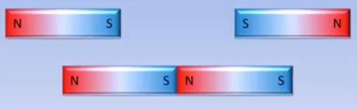

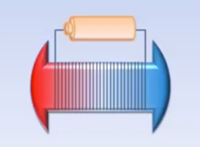
2. Regel

- ……………………………………………………………………………………………………………………………………………..…………………………………….

……………………………………………………………………………………………………………………………………………..…………………………………….

……………………………………………………………………………………………………………………………………………..…………………………………….

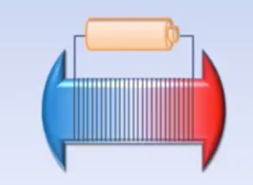
3. Regel

- ……………………………………………………………………………………………………………………………………………..…………………………………….

……………………………………………………………………………………………………………………………………………..…………………………………….

……………………………………………………………………………………………………………………………………………..…………………………………….

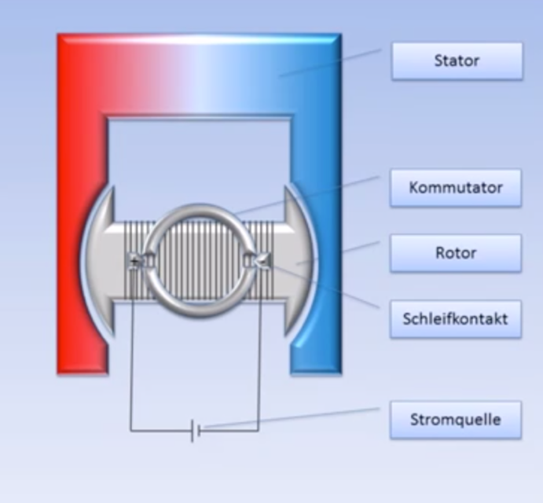
Aufbau

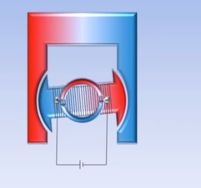
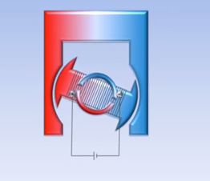
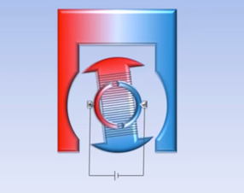
Funktionsweise

……………………………………………………………………………………………………………………………………………..……………………………………………………………………………………………………………………………………………………………………………………………….…….

……………………………………………………………………………………………………………………………………………..……………………………………………………………………………………………………………………………………………………………………………………………….…….

……………………………………………………………………………………………………………………………………………..……………………………………………………………………………………………………………………………………………………………………………………………….…….

