
"Dieses Foto" von Unbekannter Autor ist lizenziert gemäß CC BY
After you have read and found out how Sherlock Holmes solved the case, write a letter to him telling him how you liked the story, the characters and Mr. Holmes’ role in solving the case.

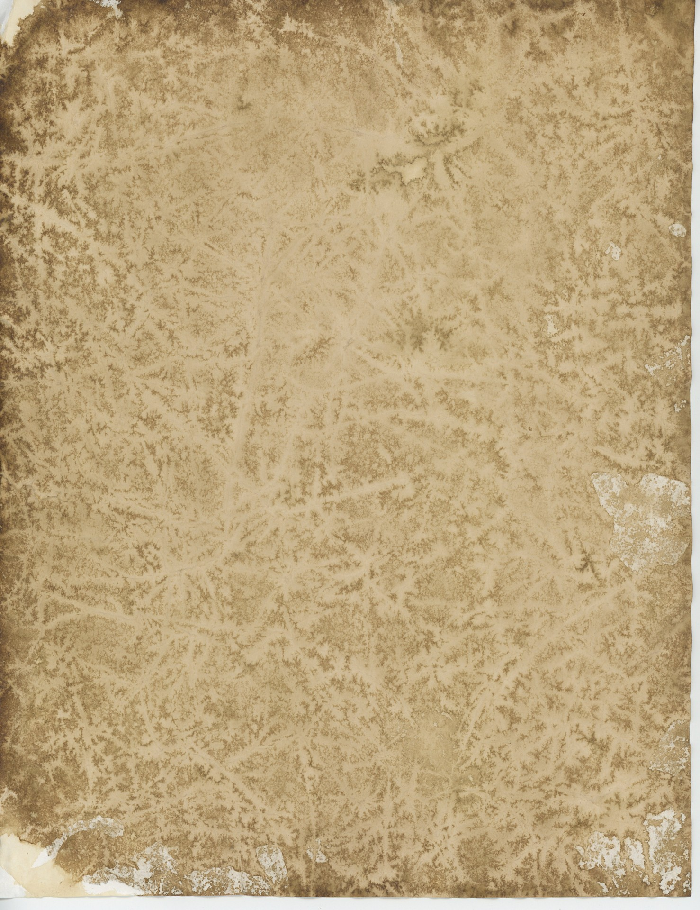

_______________________ ,
________________________________________________________
________________________________________________________
________________________________________________________
________________________________________________________
________________________________________________________
________________________________________________________
________________________________________________________
________________________________________________________
________________________________________________________
________________________________________________________
________________________________________________________
________________________________________________________
________________________________________________________
________________________________________________________
________________________________________________________
________________________________________________________
________________________________________________________

Yours sincerely,
______________

After you have read and found out how Sherlock Holmes solved the case, write a letter to him telling him - how you liked the story
- what clues were most interesting or surprising for you
- at what point of the story you found out who the real murderer was
- how and what you think of Jonas Oldacre and what should happen to him next
- what you think about Mr. Holmes’ role in this case

You should start your letter like this:
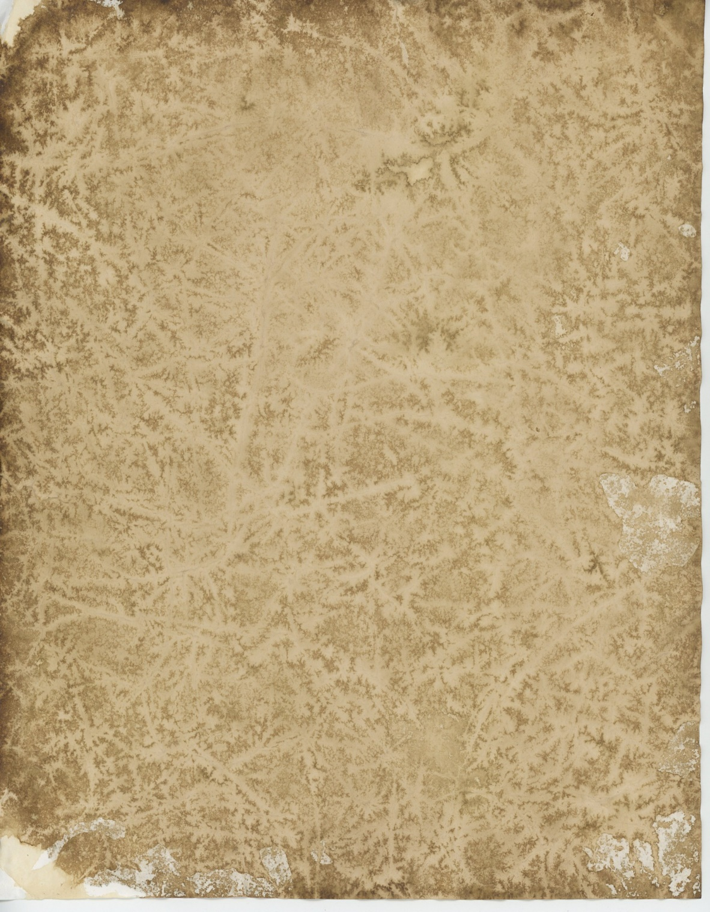

Dear Mr. Holmes,
__________________________________________________________
__________________________________________________________
__________________________________________________________
__________________________________________________________
__________________________________________________________
__________________________________________________________
__________________________________________________________
__________________________________________________________
__________________________________________________________
__________________________________________________________
__________________________________________________________
__________________________________________________________
__________________________________________________________
__________________________________________________________
Yours sincerely,
______________

After you have read and found out how Sherlock Holmes solved the case, write a letter to him and tell him - how you liked the story
- what was really interesting or surprising for you
- when you found out who the real murderer was
- if you like Jonas Oldacre
- what should happen to Jonas Oldacre next
- how you liked Mr. Holmes’ in this case
There is a word box to help you.
You should start your letter like this:
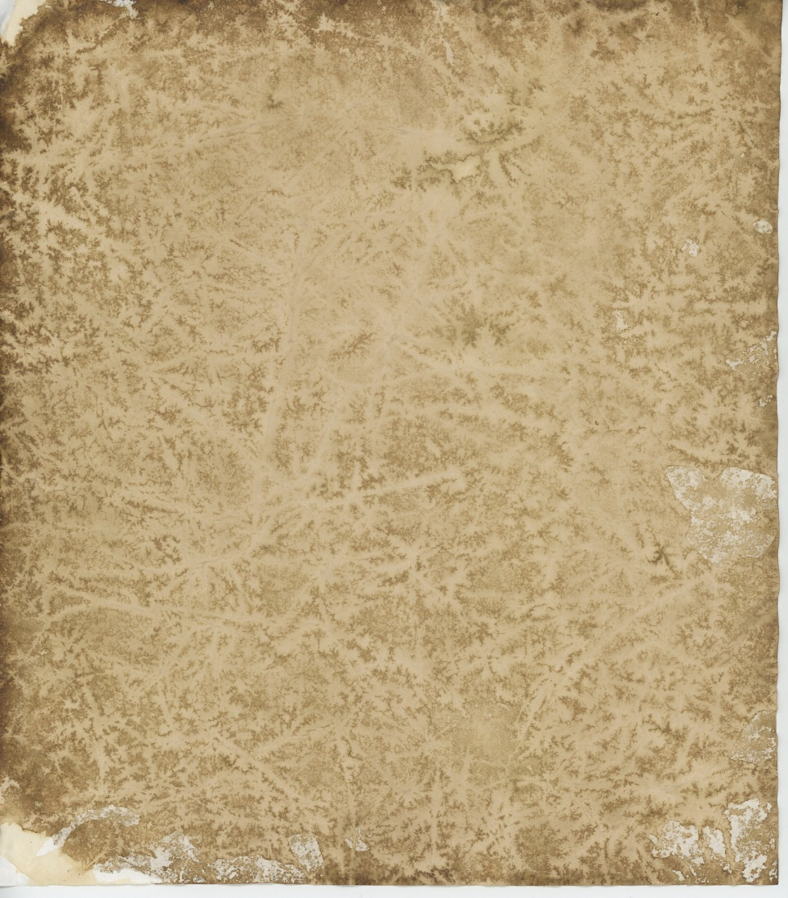

Dear Mr. Holmes,
________________________________________________
________________________________________________
________________________________________________
________________________________________________
________________________________________________
________________________________________________
________________________________________________
________________________________________________
________________________________________________
________________________________________________
________________________________________________
Yours sincerely,
______________

Word box:
I liked/ I did not like • because • in my opinion • what I liked best was/ were • what I did not like was/
were • as • I found out about • when • I think you are right/ wrong when • he should • be arrested •
get a nice present for …• great • awesome • boring • stupid

Hintergrundbild “Altes Papier”:
https://www.publicdomainpictures.net/de/view-image.php?image=110789&picture=alte-papiere-5-front, CC0

