Crack the case, Sherlock

“This seems to be a case that is impossible to solve. I love solving cases but I cannot do it on my own.
Of course, there is Dr Watson but we need your help, too.”

• First, read chapters 1 – 4.
• Later on, continue reading at your own speed.

- Find clues to prove John McFarlane’s innocence and write them down in a list.
- You can pin the clue list on the crime board.

Be prepared for the news team to interview you.
You can ask the support team for help.



Bildquellen: - https://pixabay.com/images/id-1424831/
- https://pixabay.com/images/id-151189/

The crime board team

To help solve the case create a crime board.
This connects the findings of all other teams.

• First, read chapters 1 – 4.
• Later on, continue reading at
your own speed.

- Draw and pin up pictures of the suspects.
- Find out background information about them.
- Find out their motives.
- Search for clues for John McFarlane’s guilt or innocence.

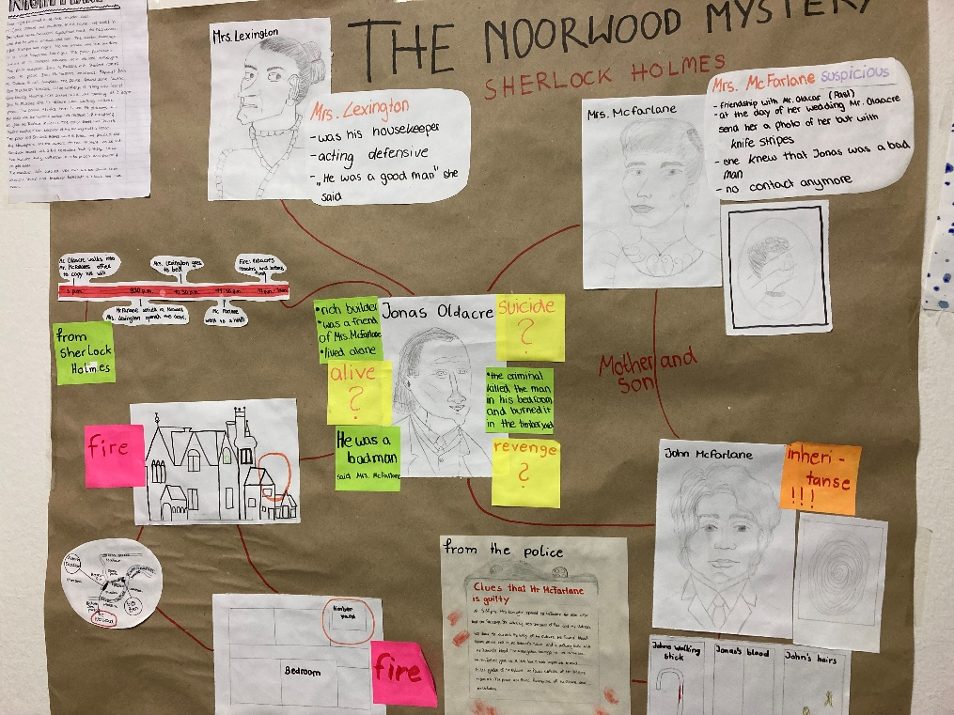

You can ask any of other teams for support.

Bildquelle: privat
The news team
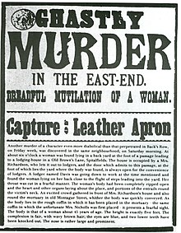
• First, read chapters 1 – 4.

• Later on, continue reading at
your own speed.

• In your team you will need

- reporters
- writers
- editors.

- News team: You work with the newspaper and would like to write a newspaper article about the murder case. Investigate, interview and write the article.

- Reporters: Interview Sherlock Holmes and Inspector Lestrade or any sergeant. Write the questions for the interview and interview the persons, take notes of the answers. Report back to the writers and editors.

- Writers: You write the article, ask the reporters for the information from their interviews with Mr. Holmes and the police. Make sure your text includes the correct information, is interesting and exciting.

- Editors: You are responsible for the final draft of the article. Read the writers’ text, check if it is interesting and engaging, also check the correct use of the language.

The news team may interview Sherlock Holmes and inspector Lestrade, and ask the support team for help.

Bildquelle: https://commons.wikimedia.org/wiki/File:Wanted_poster.jpg, als gemeinfrei gekennzeichnet

Inspector Lestrade and the police

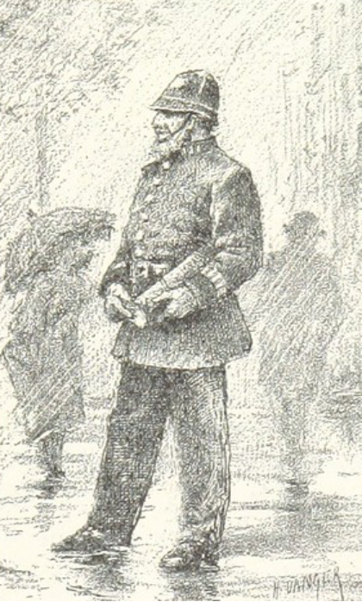
• First, read chapters 1 – 4.
• Later on, continue reading at
your own speed.

You would like to catch Mr. Oldacre’s murderer and need the help of your sergeants.
Look for clues that Mr. McFarlane is guilty and write them down in a list.

You can pin the clue list on the crime board.

Be prepared for the news team to interview you.
You can ask the support team for help.

Bildquelle: https://www.flickr.com/photos/britishlibrary/11296240443/, gemeinfrei
The support unit
• First, read chapters 1 – 4.
• Later on, continue reading at your own speed.

You are the brain of the whole CSI team.

Prepare topic vocabulary on crime and punishment for all the other teams to make it easier for them to solve the case.

You can
- draw pictures and make a pictionary,
- write explanations or
- create a word cloud (online or draw one) or
- come up with an idea of your own.

Present your results to all the other teams.



Bildquelle: https://www.schulportal-thueringen.de/pixiothek/detail?tspi=P15414, CC0

