Fourth Digit -Answer
Matching pictures and descriptions

Find the fourth digit for your lock by following the instructions:
Match the photos and the descriptions of the pictures. Write down the correct letter in the chart below:

Picture 1  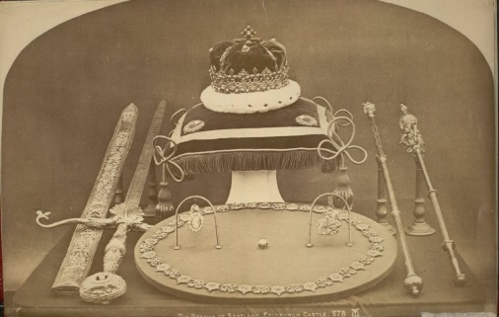  Albumen print by Alexander Inglis of the Scottish crown jewels von Inglis, Alexander - University of Edinburgh, United Kingdom - CC BY 3.0  (Quelle: https://www.europeana.eu/de/item/9200267/BibliographicResource_3000059120077) | Stirling Castle, Scotland  Stirling Castle is situated northwest of Edinburgh. This place is famous for its large fortress and old town.  Take a walk through the 14th and 15th centuries and discover the buildings and courtyards that Scottish kings and queens once called their home. James V and Mary Queen of Scots were crowned here.  Visit the castle’s interiors, the Great Hall, the kitchen as well as the Chapel Royal and the scenic gardens that offer you panoramic views for miles. Explore theimpressive grounds and learn about Scottish history. | A
Picture 2  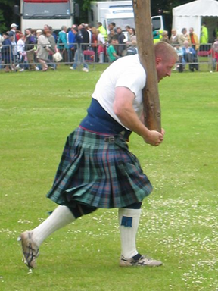  marsupium photography, 2006 Highland Games (4000821070), CC BY-SA 2.0  (Quelle: https://commons.wikimedia.org/wiki/File:2006_Highland_Games_(4000821070).jpg) | Scottish Food  Have you heard of haggis, the most  famous Scottish dish? But do you know what  it is made of? Haggis is made of sheep liver,  heart and lungs. Does that sound tasty ;)?  Well what about Scotch Broth - a hearty soup with barley and vegetables? Discover more about the excellent seafood available in Scotland: Have you ever tried fish supper or fish and chips? The fish is usually battered haddock. In the best restaurants, you’ll have a short wait as your order is freshly cooked then served with chips. Cullen Skink is a tasty soup made with smoked haddock, potatoes and onions and comes from the coast.  Scotland is also famous for its whiskies. Today you can find over 80 places where this traditional drink is  made. | B
Picture 3  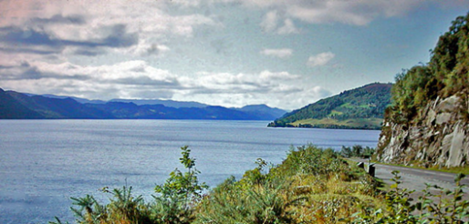  Ben Brooksbank, Loch Ness Urquhart Bay geograph-3208002-by-Ben-Brooksbank, CC BY-SA 2.0  (Quelle: https://commons.wikimedia.org/wiki/File:Loch_Ness_Urquhart_Bay_geograph-3208002-by-Ben-Brooksbank.jpg) | The Highland Games  Maybe you have already heard the name ‘Highlander’. It’s the name for a person from the northern part of Scotland.  Every year between May and September the Highland Games – a test of skill and strength - take place in the northern part of Scotland.  The athletes take part in events like tossing the caber (a pole) and throwing the hammer. But you can also admire displays of pipe bands and Highland dancing.  The most important gathering is the Braemar Highland Gathering which is, traditionally, attended by the Queen and members of the Royal Family. | C
Picture 4  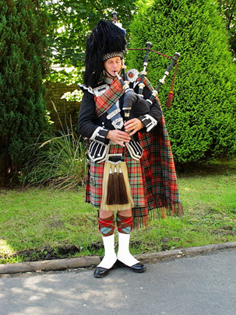  Phil Sangwell from United Kingdom, Welcoming Piper. (4938151986), CC BY 2.0  (Quelle: https://commons.wikimedia.org/wiki/File:Welcoming_Piper._(4938151986).jpg) | Edinburgh  This is the capital of Scotland and worth seeing when you visit Scotland.  It is not the biggest city of Scotland, only about 400,000 people live here. But it has many historic sights to offer. You can visit Edinburgh Castle and Holyrood Palace.  Scottish Kings and Queens have lived there for many centuries. And there is Arthur’s Seat, an old volcano. What about shopping in the big department stores in Princes Street? And after that relax in Princes Street Gardens. In the summer, you can visit one of the many festivals, for example the Fringe Festival with street performers, music and comedy and the Royal Military Tattoo. | D
Picture 5  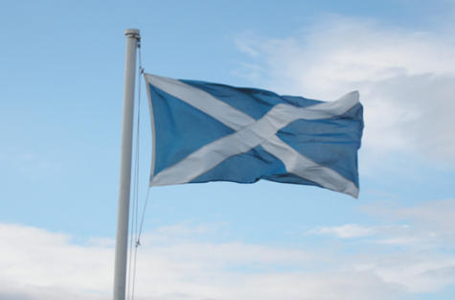  W. L. Tarbert, Saltire, als gemeinfrei gekennzeichnet, Details auf Wikimedia Commons  (Quelle: https://commons.wikimedia.org/wiki/File:Saltire.jpg) | The Saltire  This flag is part of Scotland's identity. The Scottish flag has a white cross on a blue background. The Saltire is from the cross of St Andrew, Scotland's patron saint. There is a legend that King Angus I of Scots prayed to St Andrew and a vision of the cross of  St Andrew was seen, white against a blue sky. This helped the Scots to victory. You will see the flag flying in many places throughout the country.  The cross has also become part of the Union Flag, a symbol of the United Kingdom. | E
Picture 6  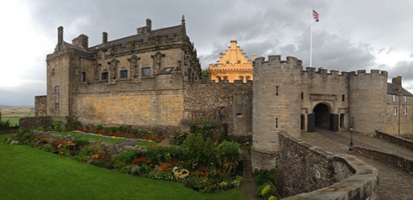  Julien.scavini, Stirling Castle sca3, CC BY-SA 4.0  (Quelle: https://commons.wikimedia.org/wiki/File:Stirling_Castle_sca3.jpg) | Loch Ness  This is a big lake, one of the biggest  in Scotland. It is famous for the Loch Ness  monster. There have been many expeditions to find Nessie, but nobody knows if Nessie really exists. Many people tell stories about Nessie and say that they have seen the monster. Today there is a museum and an exhibition about Nessie in Drumnadrochit, a village near the lake. Beside the lake you can find the ruins of Urquhart Castle. It’s a popular place with tourists, because there is a beautiful view of the lake there. | F
Picture 7  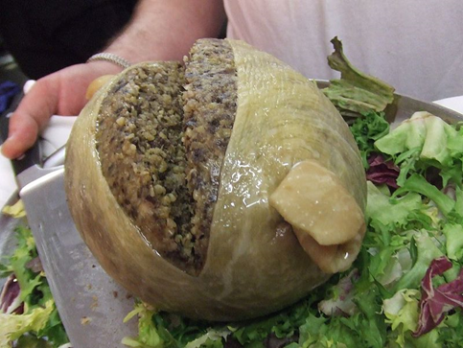  Tess Watson, Haggis with a CC license, CC BY 2.0  (Quelle: https://commons.wikimedia.org/wiki/File:Haggis_with_a_CC_license.jpg) | The Scottish Crown Jewels  Did you know that the Scottish Crown Jewels are the oldest official pieces of jewellery in the British Isles? They consist of a crown, a sword and a sceptre, all of which date from the 15th and 16th centuries. It is believed that the Silver Sceptre was a gift from Pope Alexander VI in 1494 to King James IV. The Crown of Scotland was made for King James V in 1540.  After the Union of Scotland and England in 1707 the new parliament of the United Kingdom was in London. So the Crown Jewels were locked away in Edinburgh Castle. After a campaign by Sir Walter Scott, they were re-discovered in 1818 still in their protective linen covers.  Together with the Stone of Destiny, these symbols of Scotland can be seen in the Crown Room at Edinburgh Castle. | G
Picture 8  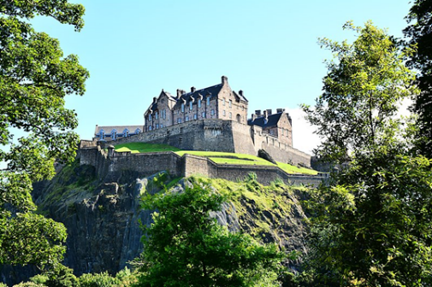  Mike McBey, Edinburgh Castle, Scotland (39616917421), CC BY 2.0  (Quelle: https://commons.wikimedia.org/wiki/File:Edinburgh_Castle,_Scotland_(39616917421).jpg) | The bagpipe  When it comes to the sound of Scotland, nothing can beat the bagpipes. This famous traditional Scottish musical instrument was originally an Egyptian instrument. Experts think that it was introduced to Scotland during Roman times. If you go to Glasgow, you can discover the history of the Great Highland Bagpipe in the National Piping Centre. You can even play the instrument yourself!  The World Pipe Band Championships are organised in Glasgow each year in August and in Edinburgh the Royal Edinburgh Military Tattoo is a spectacular event with one thousand musicians, pipers, drummers and dancers. | H

Now find the matching letters and numbers:

Picture 1 | Picture 2 | Picture 3 | Picture 4 | Picture 5 | Picture 6 | Picture 7 | Picture 8
G | C | F | H | E | A | B | D

Now solve the following equation:
(GF + EB) – (CH + FD) = YOUR DIGIT___________________
(13 +57) – (24 +38) = 8
70-62 = 8

Source: Source: https://www.scottishtours.co.uk

