The American School system
1. Watch the film about an American high school and fill in the grid with the
information presented in the film (https://youtu.be/TpdoYhT43rU).

In the USA, students start their education in ____________________ (at age 5) and finish at the end of _________ grade. After that they _____________and begin
_______________or start a___________________.

1. | - from kindergarten to fifth or sixth grade
2.middle school | - for students from _______
3. | - for students from grade 9 to 12
high school students  are called /referred to as | - freshmen  - sophomores  -  -
some schools | - from kindergarten to grade_____
schedules | - morning__________  - l________ b__________  - afternoon break for younger students: ______________
changes for students: | - younger students: the______ teacher________ ________  - older students change_________and have____________  teachers
the school faculty:  - the_____________:  - the_____________:  - the_____________:  - the counselor:  -________________:  -ELD teachers: | - the person in charge of the school  - the person second-in-command  - supports staff and helps students  - helps ____________ with social and emotional issues  and advises them on taking the right ______________  - teach __________and _____________students  - specialised in ________ __________to English learners  in the area of ___________, ________________or  _______________
before and after school  programmes:  after school activities: | - ______________with the work the students ___________  during the day  - ranging from __________to academic _____________

2. With a partner compare the American school system to your own school and the German
school system. What is different, what is the same?
Include the different types of school, the schedule, faculty and after school activities.

3. Present your own school to an American teenager who is going to spend the next academic year at your school.
Make a presentation or a video introducing your school which is about 3-5 minutes.
Your presentation should include:
- number of students
- faculty
- library
- cafeteria
- classes and when they start
- science lab, computer lab
- gym and after school activities
- school rules (dos and don’ts)

Have fun !

Help:

Hi! I’m ___________and I attend the____________ school. I’d now like to present our school to you. If you’re planning to come to our school, I hope this video will help you find your way around and you can learn about some of the rules here. Let me take you on a little tour. …

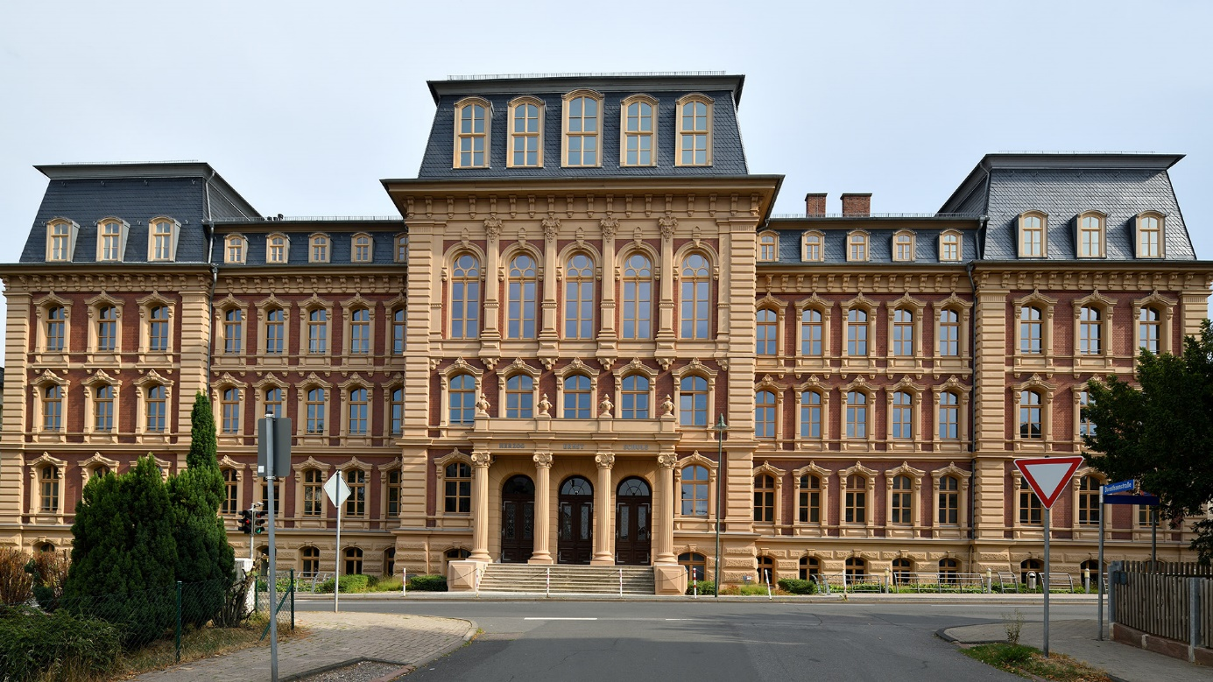
www.kgs-gotha.de

