Praxisbeispiel Ausbildungsberuf: Steuerfachangestellte/r
Schuljahrgang | Fach | Unterrichtseinheit/Stundenthema | Schulform
1. Ausbildungsjahr | Englisch | Where’s the tax adviser’s office? | Berufsschule

Kompetenzschwerpunkt | - Leseverstehen (berufsbezogene Texte mit unterschiedlichen Anteilen an bekanntem und unbekanntem Wortschatz verstehen) und/oder  - Hörverstehen (Texte, die von Muttersprachlern überwiegend in Standardsprache gesprochen werden, verstehen)
Lehrplanbezug | - Thüringer Lehrplan für die Berufsschule Beruf: Steuerfachangestellter/ Steuerfachangestellte (Stand 2012)  - Lehrplanthema: Angaben zum eigenen Ausbildungsbetrieb (Personen und deren Zuständigkeiten - Abteilungen)  - Stundenthema: Where’s the tax adviser’s office?
Organisatorische Voraussetzungen | - Zugang zur TSC zum Erhalt der Aufgaben und zur Abgabe des Ergebnisses
Technische Voraussetzungen | - SuS sollten zu Hause über Endgeräte mit Internetzugang verfügen
Methodische Voraussetzungen | - unterschiedliche Techniken beim Lesen und/oder Hören situationsgerecht anwenden  - sprachliches und berufliches Wissen als Verstehenshilfe nutzen  - Wichtiges von Unwichtigem trennen  - unbekannten Wortschatz unter Nutzung von Hilfsmitteln erschließen  - erfasste Inhalte effizient und zielorientiert notieren und strukturieren
Lerngruppeninterne Absprachen | - nicht erfoderlich, da Einzelarbeit
Bemerkungen | - keine
Differenzierung | - SuS können sowohl ihr Lerntempo als auch ihr Herangehen an die Aufgaben-lösung individuell gestalten, z. B. durch mehrfaches Lesen der Texte, durch die Anwendung verschiedener Lesetechniken, durch gleichzeitiges Hören der Texte, und sie können selbst bestimmen, wie viele und welche Vokabeln sie mit Hilfsmitteln nachschlagen  - SuS können die Texte hören anstatt zu lesen bzw. beides parallel tun, um mehrere Lernkanäle zu nutzen
Feedback | - Abgabe des „Floorplans“ über TSC oder per E-Mail
Zeitumfang | - 1 Unterrichtsstunde

Where’s the tax adviser’s office?

Situation and task:
You have decided to do some practical training in the UK. It is your first day at your new tax adviser’s office. Sally, a co-worker, is trying to give you a short overview of the most important rooms, people and places in the office. It is quite confusing for you, so you decide to make a floorplan for yourself. Unfortunately, Sally does not mention where you can find the office of the tax adviser, Mrs Mertens. She is the most important person in the office. While Sally is talking to you, you fill in your floorplan so that in the end you will know for sure where the tax adviser’s office is. Include all the rooms and places as well as the tax adviser’s office which you should circle.

The reception area
This area has recently been redecorated and newly furnished. Do you like it? Well, there is even a little white marble fountain in the middle! All the clients are very impressed by it. The reception area stretches across the whole front of the building. The lift is just behind it on the right-hand side of the building.

The post room and archive
This room is between the gents’ toilet and the auditor’s office. The post room and archive are in one room on the left-hand side of the main corridor. The post room is important because most of the correspondence with clients and the tax authorities passes through here. Letters, faxes and newsletters to clients are handled from here and Sandra, who works here, knows all the office gossip. In the archive you can find old documents. Laws force us to keep balance sheets and profit and loss accounts or other documents for a certain length of time. To be quite honest, it is a bit dusty in there.

The lift
Be really careful with the lift. Sometimes it does not work. It is between the reception area and the secretary’s office. Its doors open onto the main corridor. It is opposite the ladies’ toilet. It was always very popular, but since it got stuck between the third and fourth floor last week, people seem to be avoiding it.

The main corridor
This runs down the centre of the building from the reception area at the front to the staff canteen at the back. As we say … it is the heart of our office. On the walls you can see photos of our team and some paintings by Luise, our secretary.

The conference room
This is opposite the personnel department, next to the staff canteen. It used to be very popular with our staff, as all the important meetings took place there. Sometimes our discussions got very heated. Unfortunately, in 2020 this situation started to change. Due to the coronavirus, larger groups of people are not allowed to meet there anymore as there is not enough space to safely social distance. So now there are mostly one-to-one meetings with clients.

The main secretary’s office
This is between the lift and the department called “salaries and wages” on the right-hand side of the building. Make sure you knock on the door first before you enter, as Mrs. Francis thinks it is impolite to just pop into her room. As you can see her behind a glass window, you are better off deciding whether she looks really busy and to maybe come back later if she seems to be concentrating on something.

The annual accounts department
This is next to the department for salaries and wages and across the corridor from the auditor’s office. Its staff have had a lot of stress over the years and can’t seem to relax.

The auditor’s room
Our auditor’s name is Mr. Turner. He has got nothing but trouble at the moment. His telephone just doesn’t stop ringing. We urgently need to employ a second auditor in the near future. His room is between the post room and office 1, that’s what we call our first office for the tax adviser’s assistants. It is on the left-hand side of the building.

The personnel department
Life has been stressful in this department because the company has had to make several employees redundant this year. It is opposite the conference room. It is also just in front of the staff canteen – most convenient for the next cup of coffee.

Office 2
In this office there are four employees who are all tax adviser’s assistants, by the way. It is between office 1 and the personnel department, on the left-hand side of the main corridor.”
Salaries and wages
This is situated between the annual accounts department and the secretary’s office. It is opposite the post room and the auditor’s room. Right now, because of the corona crisis and the changing wages and salaries for our clients’ employees, there is a lot to do there.

The gents’ toilet
This is opposite the main secretary’s office, between the ladies’ toilet and the post room. Unfortunately, it has been waiting for a face-lift for years.

The staff canteen
This stretches all the way across the back of the office at the far end of the main corridor. It is large and ultra-modern. Everyone enjoys coming here. Right now we have to practise social distancing. but the food is still great. Emma, our chef and only member of staff in the canteen, is really friendly. We all enjoy coming here. Today there is the delicious smell of fish and chips in the air, can you smell it, too?

I hope you will find your way around here soon. Now I recommend going to the tax adviser to introduce yourself.

But where is her office?

Nach: Lloyd, A.; Preier, A.: Business Communication Games. Oxford University Press 1996.

Floorplan
Use this basic floorplan and use Sally’s explanations. Add all the rooms and find the tax adviser’s office.

Listening comprehension:
Room | Audio Track
The reception area | 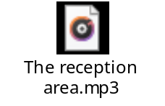
The post room and archive | 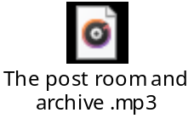
The lift | 
The main corridor | 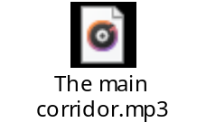
The conference room | 
The main secretary’s office | 
The annual accounts department | 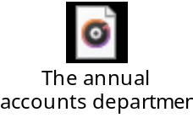
The auditor’s room | 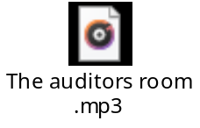
The personnel department | 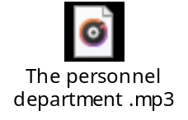
Office 2 | 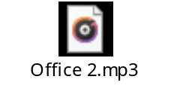
Salaries and wages | 
The gents’ toilet | 
The staff canteen | 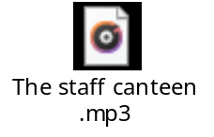

Key: (student’s example) with mistakes

